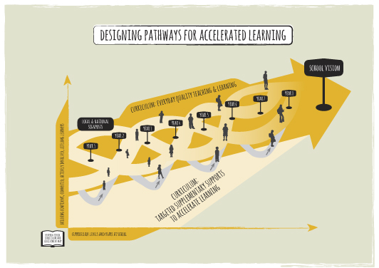

School curriculum and achievement action plan template
It is expected that this plan would be built up and reviewed over time. The planning and review questions, and implementation alerts can be used to scaffold the process.

School curriculum’s expected outcomes for students
School’s annual plan goals
 | After 1 year at school | After 2 years at school | After 3 years at school | At the end of year 4 | At the end of year 5 | At the end of year 5 | At the end of year 7 | At the end of year 8
Student progress from one year to the next in response to the school curriculum
Mathematics
National signposts associated with this progress
Classroom signposts associated with this progress
Student learning behaviours or achievement outcomes that would trigger a Tier 2 supplementary support
Tier 2 supplementary supports available
Monitoring student progress during and after the Tier 2 supplementary support was initiated
Student learning behaviours or achievement outcomes that would trigger a Tier 3 supplementary support
Tier 3 supplementary supports available
Monitoring student progress during and after the Tier 3 supplementary support was initiated
Writing
National signposts associated with this progress
Classroom signposts associated with this progress
Student learning behaviours or achievement outcomes that would trigger a Tier 2 supplementary support
Tier 2 supplementary supports available
Monitoring student progress during and after the Tier 2 supplementary support was initiated
Student learning behaviours or achievement outcomes that would trigger a Tier 3 supplementary support
Tier 3 supplementary supports available
Monitoring student progress during and after the Tier 3 supplementary support was initiated
Reading
National signposts associated with this progress
Classroom signposts associated with this progress
Student learning behaviours or achievement outcomes that would trigger a Tier 2 supplementary support
Tier 2 supplementary supports available
Monitoring student progress during and after the Tier 2 supplementary support was initiated
Student learning behaviours or achievement outcomes that would trigger a Tier 3 supplementary support
Tier 3 supplementary supports available
Monitoring student progress during and after the Tier 3 supplementary support was initiated

